

Nigerian Journal of Physics (NJP)
ISSN online: 3027-0936
ISSN print: 1595-0611
DOI: https://doi.org/10.62292/njp.v35i4.2026.539
Volume 35(4), December 2026


Synthesis of Polyvinylidene Fluoride-Graphene Based Polymer Nanocomposite with Enhanced Piezoelectric Properties

¹Aliyu Abdulraheem, ²Sadiq Umar, ²Abubakar Sadiq Sanda and ¹Amoka Abdelghaffar Abdelmalik

¹Department of Physics, Ahmadu Bello University, Zaria, Nigeria.
²Department of Physics, Ibrahim Badamasi Babangida University, Lapai, Nigeria.

*Corresponding Author’s Email: aliyuelokene@gmail.com

Keywords:  PVDF-Graphene Nanocomposite,  Piezoelectric Voltage Constant,  Resistivity | ABSTRACT  Piezoelectric energy harvesting is attracting interest for self-powered devices. The properties of polymer nanocomposites depend strongly on how they are prepared. Polyvinylidene fluoride (PVDF) combined with graphene offers promise, yet melt intercalation remains under explored. In this study, the incorporation of graphene nanoplatelets (GNPs) into PVDF via melt intercalation and evaluating their impact on piezoelectric, dielectric, and mechanical performance have been conducted. The PVDF was doped with 0.5 wt% and 1.0 wt% GNPs as filler material through melt intercalation. The piezoelectric voltage constant, dissipation factor, modulus of elasticity, and resistivity were evaluated to assess improvements in performance. There was an enhancement in piezoelectric voltage constant due to addition of GNPs. The piezoelectric voltage constant increased by 59.7% and 5.5% with the addition of 0.5 wt% and 1.0 wt% GNPs respectively, suggesting better mechanical energy conversion efficiency at lower filler concentration. Lower dissipation factor was observed with increase in the concentration of filler, around power frequency (50 Hz), while maintaining higher resistivity, indicative of good dielectric performance. Mechanical analysis revealed that the Young’s modulus improved with increase in GNPs addition, confirming enhanced stiffness and stress transfer. Although 1.0 wt% loading of GNPs shows better dielectric performance, 0.5 wt% graphene loading significantly enhanced PVDF’s piezoelectric sensitivity and mechanical strength, making it a promising material for flexible sensors and energy-harvesting applications.
Submitted: 25 May 2026
Accepted: 15 June 2026
Published: 02 July 2026

INTRODUCTION
Polyvinylidene fluoride (PVDF) is a semi-crystalline polymer that has gained significant attention in the field of materials science due to its remarkable piezoelectric properties. As a piezoelectric material, PVDF is capable of converting mechanical energy into electrical energy and vice versa, making it highly valuable for applications in sensors, actuators, energy harvesting devices, and wearable electronics (Aabid et al., 2021; Shi et al., 2023). PVDF stands out among polymer materials due to its high flexibility, chemical resistance, ease of processing, excellent thermal, mechanical, and piezoelectric properties, which makes it widely adoptable as host polymer matrix in the development of polymer nanocomposite for energy harvesting or candidate for flexible and lightweight piezoelectric devices (Cerrada et al., 2023; Shi et al., 2023). Its piezoelectric property is due to the presence of the β phase, which possesses a polar dipole moment that results in increase piezoelectricity(Stoyanova et al., 2024). However, the piezoelectric performance of pure PVDF is inherently limited by its relatively low dielectric constant and piezoelectric coefficients compared to traditional ceramic piezoelectric materials like lead zirconate titanate (PZT) (Stamatellou, 2023).
To address these limitations, researchers have explored the incorporation of conductive nanoparticles into the PVDF matrix (Cerrada et al., 2023; Stoyanova et al., 2024). The addition of nanoparticles such as carbon nanotubes (CNTs), graphene, metal nanoparticles (e.g., silver, gold), or metal oxides (e.g., zinc oxide, titanium dioxide) has been shown to enhance the piezoelectric properties of PVDF (Peña-Oliveras et al., 2024). This improvement is attributed to several factors, including the increased crystallinity of the PVDF β-phase, which is the most electroactive phase responsible for its piezoelectric behavior, as well as the improved electrical conductivity and dielectric properties imparted by the nanoparticles (Cerrada et al., 2023).
In addition, the interaction between the nanoparticles and the PVDF matrix can lead to the formation of micro-capacitors within the composite, which enhances the charge storage and polarization capabilities of the material (Roy et al., 2016). This, in turn, results in a higher piezoelectric output. Also, the size, shape, and concentration of the nanoparticles play a critical role in determining the extent of improvement in the piezoelectric properties (Cerrada et al., 2023; Roy et al., 2016; Stoyanova et al., 2024). Higher nanoparticle loading enhances conductivity but compromises ductility, limiting applicability in flexible electronics (Chen et al., 2025). The use of low concentration graphene nanoparticles can enhance piezoelectric property while maintaining ductility.
The relationship between nanoparticle morphology, dispersion, and the electromechanical response of PVDF is also dependent on the processing techniques. Electrospinning, as a processing technique, aligns polymer chains under high electric fields with nanoparticles to maximize β-phase content and uniaxial piezoelectric anisotropy (Hasanzadeh et al., 2021; Paralı et al., 2024). While solution casting with controlled solvent evaporation rates can optimize nanoparticle distribution, minimizing agglomeration, which is a common issue that disrupts polarization and mechanical integrity (Ramadan et al., 2014). Thermal annealing, on the other hand, can reorganize crystalline domains, however, excessive temperatures risk degrading the polymer matrix (Sencadas et al., 2009). Melt intercalation is a solvent free approach, direct but faces filler dispersion issues (Albdiry, 2024). In most research involving the addition of graphene as filler in PVDF matrix, preparation methods such as solution casting and electrospinning are the mostly applied (Kushwaha et al., 2026; Widakdo et al., 2022). However, despite extensive work using solution casting and electrospinning, the adoption of the solvent free and direct mixing through melt intercalation on graphene dispersion and piezoelectric performance remains under-explored.
In the present study, the aim is to develop a PVDF-doped nanocomposite adopting melt intercalation technique and using graphene nanoplatelets as filler materials and PVDF as polymer matrix for improved piezoelectric, dielectric, and mechanical properties while maintaining an optimal filler concentration. It will highlight the impact of the addition of moderate concentrations of conducting graphene nanoplatelets to the piezoelectric, dissipation, resistivity properties of pristine PVDF polymer material.

MATERIALS AND METHODS
Here the materials, experimental procedures, and characterization techniques employed to investigate the effect of incorporating Graphene Nanoplatelets (GNPs) into polyvinylidene fluoride (PVDF) to enhance its piezoelectric properties is presented and discussed. The methodology is designed to systematically evaluate the influence of graphene concentration on the dielectric properties and piezoelectric performance of PVDF composites. The methods involve the preparation of graphene-PVDF composite films and characterization using various analytical techniques. All procedures adhere to standard laboratory protocols to ensure reproducibility and reliability of results.

Materials
The materials used in the study include: Polyvinylidene fluoride (PVDF) as the polymer matrix, Graphene nanoplatelets (GNPs) as the conducting filler, and Laboratory prepared deionized water.

Methods
Preparation of Graphene-PVDF Polymer Nanocomposite
The polymer nanocomposite samples were prepared using the standard melt compounding technique (Albdiry, 2024). The 0.5% w/w of graphene nanoplatelets was directly mixed with PVDF polymer materials. The mixture was then fed into a two-roll mill machine rolling at 54 rpm to ensure homogeneous dispersion of the nanoparticles within the polymer matrix. The temperature of the roller was increased to 50℃ due to the nature of the material. Measured sample was placed between the roller, repeating thermal contact of the roller in order for the sample to transform to a molten form. The molten form of the polymer was placed on a molder to obtain an 80×60 mm shape and taken to a compressing machine where it was compressed to fit into the molder for a required shape. After compressing it, the molder containing the polymer nanocomposite was removed from the compressor and then allowed to cool at room temperature, after10 min, an 80×60 mm hard-Solid polymer was obtained from the molder. The same procedure was followed, but this time using 1.0% w/w grapheme nanoplatelets.

Characterization of the Prepared Polymer Nanocomposites
The prepared composite samples were characterized to evaluate the effect of graphene nanoplatelets addition on the dielectric and piezoelectric properties of host and pristine PVDF.
Dissipation factor: The dissipation factor of the prepared samples was directly read from a digital programmable LCR bridge (Hioki IM3533-01) setting the frequency range from 10Hz to 200 kHz and 15 frequency points.
Resistivity: The resistance of the material was measured from the Hioki IM3533-01 LCR bridge and then the resistivity evaluated from Equation (1) using the geometry of the test cell.
$ρ=R.\frac{A}{l}$ (1)
Where R is the resistance of the material, A is the cross-sectional area of the plate of the test cell, and l is the spacing between electrodes of the test cell or thickness of the polymer material.

Piezoelectric Voltage Constant
Piezoelectric voltage constant (g) is defined as the electric field generated by a piezoelectric material per unit of mechanical stress applied. It was evaluated from Equation 2 (Bernard et al., 2017):
$g=\frac{E}{σ}=\frac{V}{dσ}$ (2)
Where the electric field, E ₌$\frac{V}{d}$ in unit volt per meter, V is the measured output voltage by the polymer nanocomposite when mechanical stress is applied using the tensile tester and d is the thickness of the polymer nanocomposite material (in unit meter). σ is the stress applied to the material in N/m².

Mechanical Property
The stress-strain curve was obtained from the HST computer-controlled tensile tester (see Figure 5). The pristine polymer and polymer nanocomposites samples were prepared by cutting them into the dump bell shape. Each specimen was properly positioned in the test machine and the shoulders of the samples were firmly gripped by the upper and lower tensile grips of the tensile tester. Input parameters such thickness of the specimen, its gauge section width, and gauge section length, were imputed into the computer software. The load was then applied to the specimen.

Figure1: Tensile Strength Tester

The Young’s modulus (𝐸) is the stiffness of a material and it is calculated from the slope of the initial linear portion of the stress–strain curve, and it is defined by Equation 3(Bernard et al., 2017):
E=$\frac{Δσ }{Δε}$ (3)
where σ is the applied stress (N/m²)and ε is the corresponding strain.

RESULTS AND DISCUSSION
Frequency Dependence of the Dissipation Factor of the Polymer Nanocomposite
Dielectric property of PVDF doped with 0.5 wt% and 1.0 wt% graphene was analyzed in terms of dissipation factor (D) and resistivity as functions of frequency (f) in the range of 10 Hz to 200 KHz at 30°C. Figure 1(a) and (b) show the respective frequency dependence of dissipation factor of the 0.5 wt% and 1.0 wt% doped PVDF polymers.

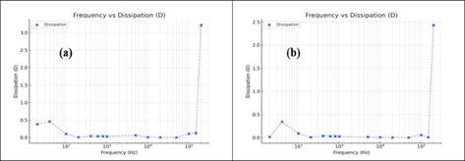
Figure 2: Frequency Dependence of Dissipation Factor of 0.5 wt% & 1.0 wt% Graphene-PVDF Polymer Nanocomposites

As shown in both Figures 2 (a) and (b), at low frequencies between 10 to 150 Hz, the dissipation factor shows stronger frequency dependence. The noticeable dissipation peak at about 0.5 and 0.35 respectively in Figures 2 (a) and (b) in the frequency range of 10 – 100 Hz suggests that charge carriers accumulate at the electrode–sample interface due to interfacial polarization, with graphene pathways facilitating conduction losses. However, weak or frequency independent dissipation values are seen in the frequency range of 150 Hz to 100 kHz. Research by Mohammed (2022), show dissipation factor reduction with addition of ZnO nanoparticles in a PVDF-based polymer composite.
Lower dissipation factor is observed in 1.0 wt% doped PVDF (i.e 1.0GPNC) compared with the 0.5 wt% doped PVDF (i.e 0.5GPNC).

Resistivity-Frequency Dependence of the Developed Polymer Nanocomposites
Figures 3 show the relationship between resistivity and frequency in the range of 1 kHz to 200 kHz for the developed polymer nanocomposites

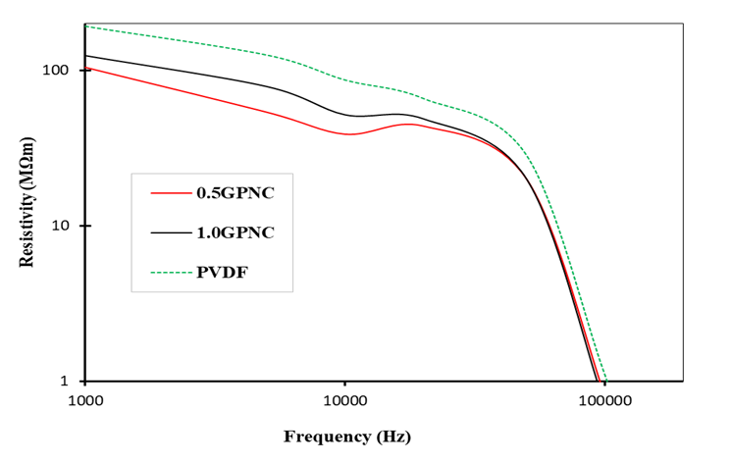
Figure 3: Frequency Dependence of Resistivity of the Developed Polymer Nanocomposite 0.5 wt% (0.5GPNC) & 1.0 wt% (0.5GPNC) Doped at 30°C

In Figure 3, the resistivity of the samples decreased slowly with an increase in frequency in both polymer nanocomposites. This is because at higher frequencies, the dipoles or charges in the polymer material can not keep up with the rapidly changing applied field hence more current flow. There was a reduction in the resistivity of PVDF with the addition of graphene nanomaterial. However, the resistance in the PVDF loaded with 1.0 wt% graphene is higher than PVDF of 0.5 wt% loading at lower frequencies. . The higher resistivity and less dissipation shows the PVDF loaded with 1.0 wt% graphene has better dielectric performance compared to the 5 wt% loaded composite. In a similar study, Kushwaha et al. (2026), reported enhanced conductivity (reduced resistivity) with the addition of percentage graphene in PVDF. Khassi et al. (2019), also reported increased conductivity with increase in grapheme oxide addition of 1wt% and 2wt%. However, further increase in filler concentration of 3wt% resulted in a reduction in conduction from 2.51 at 2 wt% to 2.16 Sm⁻¹. The observed decrease in conductivity on increasing the filler concentration from 0.5 wt% to 1.0 wt% could be due to localized charge accumulation that impede conduction.

Piezoelectric Property of Doped PVDF
Table 1 shows the estimated piezoelectric voltage constant of the developed polymer nanocomposites and the pristine polymer material.

Table 1: Piezoelectric Voltage Constant of the Developed Samples
Sample Name | Composition | Piezoelectric voltage constant (Vm/N)
Pristine PVDF | PVDF | 201 × 10⁻³
0.5GPNC | PVDF + 0.5 wt% Graphene NPs | $$320×{10}^{-3}$$
1.0GPNC | PVDF + 1.0 wt% Graphene NPs | $$212×{10}^{-3}$$

There is an enhancement in the piezoelectric voltage constant of PVDF with the addition of graphene nanoplateletss. Research has shown that incorporation of nanoparticles in the matrix of PVDF enhances the polar β-phase through Coulombic interaction with PVDF chains. Thus, nanofillers in the PVDF matrix influence the ferroelectric properties and improve the piezoelectric voltage constant (Mondal et al., 2023).
The measured piezoelectric voltage constant (g ≈ 320 ×10⁻³ VmN⁻¹ for 0.5 wt% graphene and 212×10⁻³ VmN⁻¹ for 1.0 wt% graphene) is comparable to values reported for some PVDF-based composites. Bernard et al. (2017) reported a piezoelectric voltage constant of 66 ×10⁻³ VmN⁻¹ for pure PVDF. The superior performance of the developed polymer nanocomposite in this study compared to the pristine PVDF is suggestive of grapheme nanoplatelets capacity to provide a more effective pathway for dipole alignment and stress transfer, enhancing piezoelectric output even at low filler content in the polymer (Cerrada et al., 2023).

Mechanical Property of the Developed Polymer Nanocomposite
The stress-strain curve for the developed polymer nanocomposite is shown in Figure 4 and 5 for the 0.5 wt% and 1.0 wt% loaded graphene nanoplatelets in PVDF polymer.

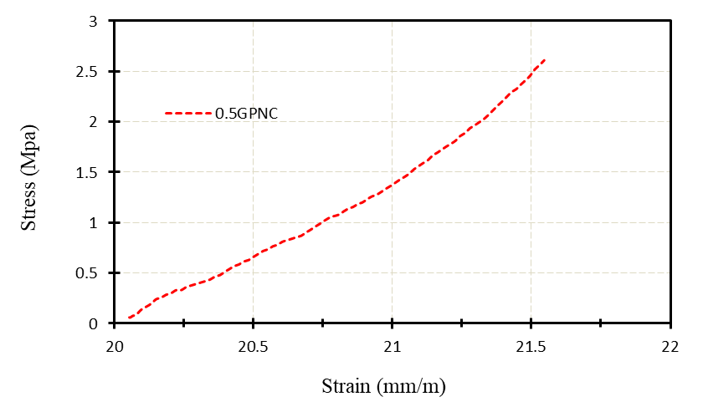
Figure 4: Stress-Strain Curve for the Developed 0.5 wt% Doped Polymer Nanocomposite

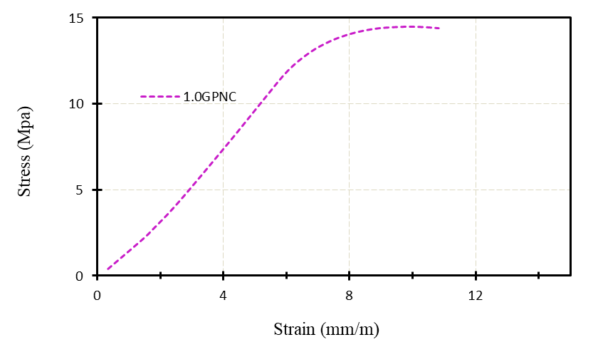
Figure 5: Curve of Stress Against Strain for the Developed 1.0 wt% Doped Polymer Nanocomposite

The stress increases linearly with strain up to around 0–12 MPa (Figure 5), reaching a peak stress of approximately 13 MPa, after which the curve gradually declines. This initial linear region indicates the elastic deformation phase where the material obeys Hooke’s law. Based on the ratio of stress to strain in this region, the Young’s modulus for PVDF doped with 0.5 wt% graphene is about 1.604 GPa as estimated from the slope of the curve while that of the 1.0 wt% doped PVDF is about 2.06 GPa. This signify an enhancement of the modulus of elasticity of the PVDF material with increase in nanoparticle addition and improved stiffness of the material. The increase in modulus is attributed to the strong interfacial bonding between the graphene nanoplatelets and the PVDF matrix, which promotes efficient stress transfer and restricts polymer chain mobility during loading. However, the mild fluctuations in stress curves at may be due to clustering or non-uniform stress distribution within the matrix, which can slightly affect ductility.

CONCLUSION
This study examined the effect of incorporating graphene nanoparticles into PVDF on its dielectric, piezoelectric, and mechanical properties. PVDF composites doped with 0.5 wt% and 1.0 wt% graphene were analyzed. The 1.0 wt% sample showed lower dielectric loss at power frequency (50 Hz) and higher resistivity, indicating better dielectric performance. The piezoelectric voltage constant increased from 201 VmN⁻¹ to 320 ×10⁻³ VmN⁻¹ for 0.5 wt%, representing a 59.7% improvement, and only 5.5% when 1.0 wt% graphene was incorporated, showing enhanced polarization at lower filler content. The Young’s modulus also increased with increase in filler addition, confirming improved stiffness with graphene addition. Graphene addition significantly improved the piezoelectric response, dielectric property, and stiffness of PVDF. The 0.5 w% graphene composite gave the best balance of properties. Graphene-PVDF composites are promising materials for flexible sensors and energy-harvesting applications. Dispersion control and microstructural analysis report are some of the limitations of the study. Future research prospects include structural study including SEM, XRD analysis, and phase quantification. The study of the structure of the developed polymer nanocomposite could provide a better understanding of its dielectric behavior and how the additions impact the crystallinity of the PVDF material.

REFERENCES
Aabid, A., Raheman, M. A., Ibrahim, Y. E., Anjum, A., Hrairi, M., Parveez, B., Parveen, N., & Mohammed Zayan, J. (2021). A Systematic Review of Piezoelectric Materials and Energy Harvesters for Industrial Applications. Sensors, 21(12), 4145. https://doi.org/10.3390/s21124145

Albdiry, M. (2024). Effect of melt blending processing on mechanical properties of polymer nanocomposites: A review. Polymer Bulletin, 81(7), 5793–5821. https://doi.org/10.1007/s00289-023-05012-z

Bernard, F., Gimeno, L., Viala, B., Gusarov, B., & Cugat, O. (2017). Direct Piezoelectric Coefficient Measurements of PVDF and PLLA under Controlled Strain and Stress. Proceedings of Eurosensors 2017, Paris, France, 3&ndash;6 September 2017, 335. https://doi.org/10.3390/proceedings1040335

Cerrada, M. L., Arranz-Andrés, J., Caballero-González, A., Blázquez-Blázquez, E., & Pérez, E. (2023). The β Form in PVDF Nanocomposites with Carbon Nanotubes: Structural Features and Properties. Polymers, 15(6), 1491. https://doi.org/10.3390/polym15061491

Chen, B., Feng, Z., Yao, F.-Z., Zhang, M.-H., Wang, K., Wei, Y., Gong, W., & Rödel, J. (2025). Flexible piezoelectrics: Integration of sensing, actuating and energy harvesting. Npj Flexible Electronics, 9(1), 58. https://doi.org/10.1038/s41528-025-00432-5

Hasanzadeh, M., Ghahhari, M. R., & Bidoki, S. M. (2021). Enhanced piezoelectric performance of PVDF-based electrospun nanofibers by utilizing in situ synthesized graphene-ZnO nanocomposites. Journal of Materials Science: Materials in Electronics, 32(12), 15789–15800. https://doi.org/10.1007/s10854-021-06132-w

Khassi, K., Youssefi, M., & Semnani, D. (2020). PVDF/TiO2 /graphene oxide composite nanofiber membranes serving as separators in lithium‐ion batteries. Journal of Applied Polymer Science, 137(23), 48775. https://doi.org/10.1002/app.48775

Kushwaha, A., Peter, A. T., Shah, F. U., & Gupta, D. (2026). Graphene-PVDF composite membrane for piezoelectric nanogenerators and lithium-ion batteries. Materials Advances, 7(2), 813–825. https://doi.org/10.1039/D5MA00960J

Mohammed, M. I. (2022). Dielectric dispersion and relaxations in (PMMA/PVDF)/ZnO nanocomposites. Polymer Bulletin, 79(4), 2443–2459. https://doi.org/10.1007/s00289-021-03606-z

Mondal, A., Singh, H. H., & Khare, N. (2023). Effect of piezoelectric coefficient and dielectric constant on the performance of polymer nanocomposite piezoelectric nanogenerator. Journal of Materials Science: Materials in Electronics, 34(4), 314. https://doi.org/10.1007/s10854-022-09415-y

Paralı, L., Tatardar, F., Koç, M., Sarı, A., & Moradi, R. (2024). The piezoelectric response of electrospun PVDF/PZT incorporated with pristine graphene nanoplatelets for mechanical energy harvesting. Journal of Materials Science: Materials in Electronics, 35(1), 41. https://doi.org/10.1007/s10854-023-11798-5

Peña-Oliveras, O., Javier-Boodhan, B., Santa, A. L., & Gonzalez-Sanchez, J. (2024). Effect of Nanostructures Addition and Enhancement of Poly (Vinylidene Difluoride) (PVDF) Energy Harvesting. Materials Sciences and Applications, 15(07), 228–244. https://doi.org/10.4236/msa.2024.157016

Ramadan, K. S., Sameoto, D., & Evoy, S. (2014). A review of piezoelectric polymers as functional materials for electromechanical transducers. Smart Materials and Structures, 23(3), 033001. https://doi.org/10.1088/0964-1726/23/3/033001

Roy, S., Thakur, P., Hoque, N. A., Bagchi, B., & Das, S. (2016). Enhanced electroactive β-phase nucleation and dielectric properties of PVdF-HFP thin films influenced by montmorillonite and Ni(OH)₂ nanoparticle modified montmorillonite. RSC Advances, 6(26), 21881–21894. https://doi.org/10.1039/C6RA00864J

Sencadas, V., Gregorio, R., & Lanceros-Méndez, S. (2009). α to β Phase Transformation and Microestructural Changes of PVDF Films Induced by Uniaxial Stretch. Journal of Macromolecular Science, Part B, 48(3), 514–525. https://doi.org/10.1080/00222340902837527

Shi, X., Sun, Y., Li, D., Liu, H., Xie, W., & Luo, X. (2023). Advances in wearable flexible piezoelectric energy harvesters: Materials, structures, and fabrication. Journal of Materials Science: Materials in Electronics, 34(3), 220. https://doi.org/10.1007/s10854-022-09536-4

Stamatellou, A.-M. (2023). PZT and PVDF piezoelectric transducers’ design implications on their efficiency and energy harvesting potential. Energy Harvesting and Systems, 10(2), 157–167. https://doi.org/10.1515/ehs-2022-0087

Stoyanova, S., Ivanov, E., Hegde, L. R., Georgopoulou, A., Clemens, F., Bedoui, F., & Kotsilkova, R. (2024). PVDF Hybrid Nanocomposites with Graphene and Carbon Nanotubes and Their Thermoresistive and Joule Heating Properties. Nanomaterials, 14(11), 901. https://doi.org/10.3390/nano14110901

Widakdo, J., Lei, W.-C., Anawati, A., Thagare Manjunatha, S., Austria, H. F. M., Setiawan, O., Huang, T.-H., Chiao, Y.-H., Hung, W.-S., & Ho, M.-H. (2022). Effects of Co-Solvent-Induced Self-Assembled Graphene-PVDF Composite Film on Piezoelectric Application. Polymers, 15(1), 137. https://doi.org/10.3390/polym15010137
.

